Take a tour of the renewed viewpoints around Lake Balaton
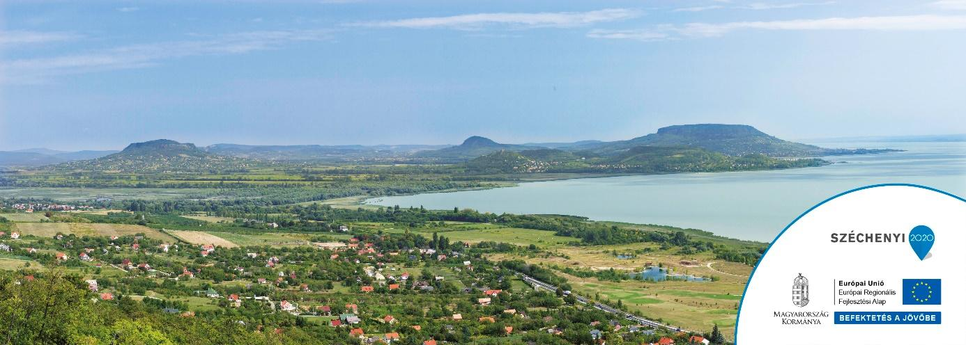
Of course, the first thing that comes to mind when thinking about Lake Balaton are the beach and bathing, but it worth to visit the nice look-out towers that are found around the lake.
In the framework of GINOP-7.1.9-17-2018-00016 project several viewpoints have been renovated or new ones created around Lake Balaton in the last few months. Some of which are accessible to tourists with reduced mobility and families with child. It is worth exploring all of them, because this way you can enjoy the unusual view from many perspectives.
You can find the viewpoints here, which are under the management of SEFAG Zrt.:
“Molyhos tölgy” panorama terrace in Szántód: https://goo.gl/maps/op4nUvcCfbnPjf9p7
The viewing terrace and experience center on the Kishegy in Balatonlelle: https://goo.gl/maps/44pwkoTUoaJbNPUe8
Both can be an excellent program opportunity during a family trip that are worth visiting at any time of the year.
In the framework of this grant other viewpoints were also renewed under the management of Bakonyerdő Zrt, as well as municipalities of Balatonföldvár and Fonyód.

